**DAY – 4**

**SELENIUM-WEBDRIVER**

1. **package ClassEx_4;**

**import org.openqa.selenium.By;**

**import org.openqa.selenium.WebDriver;**

**import org.openqa.selenium.WebElement;**

**import org.openqa.selenium.chrome.ChromeDriver;**

**import org.openqa.selenium.chrome.ChromeOptions;**

**import org.openqa.selenium.interactions.Actions;**

**import io.github.bonigarcia.wdm.WebDriverManager;**

**public class CE_1 {**

**public static void main(String[] args) throws InterruptedException {**

**ChromeOptions co = new ChromeOptions();**

**co.addArguments("-remote--cross-origin=*");**

**WebDriverManager.chromedriver().setup();**

**WebDriver driver = new ChromeDriver();**

**driver.get("https://demoqa.com/droppable/");**

**driver.manage().window().maximize();**

**Thread.sleep(7000);**

**Actions action = new Actions(driver);**

**WebElement source = driver.findElement(By.id("draggable"));**

**WebElement destination = driver.findElement(By.id("droppable"));**

**action.dragAndDrop(source, destination).build().perform(); //here no need of build because only one operation**

**driver.quit();**

**}**

**}**

**OUTPUT:**

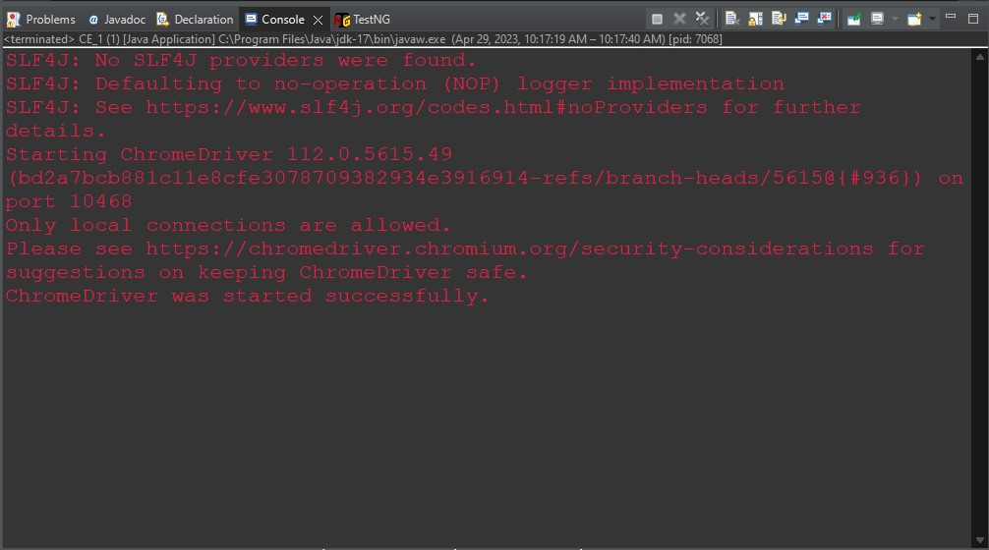

1. **package ClassEx_4;**

**import org.openqa.selenium.By;**

**import org.openqa.selenium.WebDriver;**

**import org.openqa.selenium.WebElement;**

**import org.openqa.selenium.chrome.ChromeDriver;**

**import org.openqa.selenium.chrome.ChromeOptions;**

**import org.openqa.selenium.interactions.Actions;**

**import io.github.bonigarcia.wdm.WebDriverManager;**

**public class CE_2 {**

**public static void main(String[] args) throws InterruptedException {**

**ChromeOptions co = new ChromeOptions();**

**co.addArguments("--remote-cross-origin=*");**

**WebDriverManager.chromedriver().setup();**

**WebDriver driver = new ChromeDriver();**

**driver.get("https://jqueryui.com/droppable/");**

**driver.manage().window().maximize();**

**driver.switchTo().frame(0);**

**Thread.sleep(7000);**

**Actions action = new Actions(driver);**

**WebElement source = driver.findElement(By.id("draggable"));**

**WebElement destination = driver.findElement(By.id("droppable"));**

**action.dragAndDrop(source, destination).build().perform(); // here no need of build because only one operation**

**driver.quit();**

**}**

**}**

**OUTPUT:**

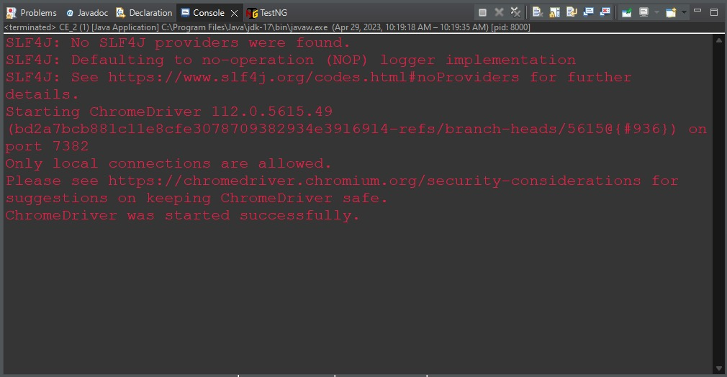

1. **package ClassEx_4;**

**import org.openqa.selenium.By;**

**import org.openqa.selenium.WebDriver;**

**import org.openqa.selenium.WebElement;**

**import org.openqa.selenium.chrome.ChromeDriver;**

**import org.openqa.selenium.chrome.ChromeOptions;**

**import io.github.bonigarcia.wdm.WebDriverManager;**

**public class CE_3 {**

**public static void main(String[] args) throws InterruptedException {**

**ChromeOptions co = new ChromeOptions();**

**co.addArguments("--remote-cross-origin=*");**

**WebDriverManager.chromedriver().setup();**

**WebDriver driver = new ChromeDriver();**

**driver.get("https://demo.guru99.com/test/delete_customer.php");**

**driver.manage().window().maximize();**

**WebElement cust_id = driver.findElement(By.xpath("/html/body/form/table/tbody/tr[2]/td[2]/input"));**

**cust_id.sendKeys("401");**

**driver.findElement(By.xpath("/html/body/form/table/tbody/tr[3]/td[2]/input[1]")).submit();**

**Thread.sleep(6000);**

**driver.switchTo().alert().dismiss();**

**driver.findElement(By.xpath("/html/body/form/table/tbody/tr[2]/td[2]/input")).clear();**

**Thread.sleep(6000);**

**WebElement cust_id2 = driver.findElement(By.xpath("/html/body/form/table/tbody/tr[2]/td[2]/input"));**

**cust_id2.sendKeys("402");**

**Thread.sleep(6000);**

**driver.findElement(By.xpath("/html/body/form/table/tbody/tr[3]/td[2]/input[1]")).click();**

**driver.switchTo().alert().accept();**

**String message = driver.switchTo().alert().getText();**

**System.out.println(message);**

**driver.quit();**

**}**

**}**

**OUTPUT:**

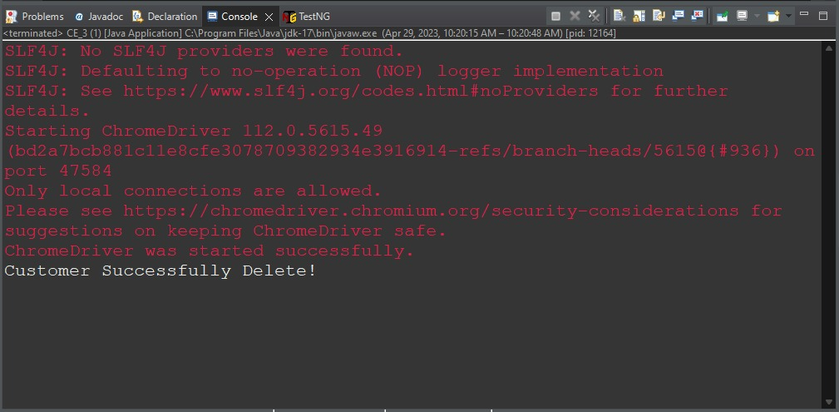

1. **package ClassEx_4;**

**import org.openqa.selenium.By;**

**import org.openqa.selenium.JavascriptExecutor;**

**import org.openqa.selenium.WebDriver;**

**import org.openqa.selenium.WebElement;**

**import org.openqa.selenium.chrome.ChromeDriver;**

**import org.openqa.selenium.chrome.ChromeOptions;**

**import io.github.bonigarcia.wdm.WebDriverManager;**

**public class CE_4 {**

**public static void main(String[] args) throws InterruptedException {**

**ChromeOptions co = new ChromeOptions();**

**co.addArguments("--remote-cross-origin=*");**

**WebDriverManager.chromedriver().setup();**

**WebDriver driver = new ChromeDriver();**

**driver.get("https://www.abhibus.com/bus-ticket-booking");**

**driver.manage().window().maximize();**

**Thread.sleep(6000);**

**WebElement from = driver.findElement(By.xpath("//*[@id=\"source\"]"));**

**from.sendKeys("Coimbatore");**

**WebElement to = driver.findElement(By.xpath("//*[@id=\"destination\"]"));**

**to.sendKeys("Chennai");**

**Thread.sleep(6000);**

**driver.findElement(By.xpath("//*[@id=\"datepicker1\"]")).click();**

**Thread.sleep(6000);**

**WebElement datepicker = driver.findElement(By.xpath("//*[@id=\"ui-datepicker-div\"]/div[2]/table/tbody/tr[3]/td[4]/a"));**

**datepicker.click();**

**JavascriptExecutor j = (JavascriptExecutor) driver;**

**j.executeScript("argum ents[0].setAttribute('value', '05/06/2023')", datepicker);**

**Thread.sleep(6000);**

**driver.findElement(By.xpath("//*[@id=\"seo_search_btn\"]")).click();**

**driver.quit();**

**}**

**}**

**OUTPUT:**

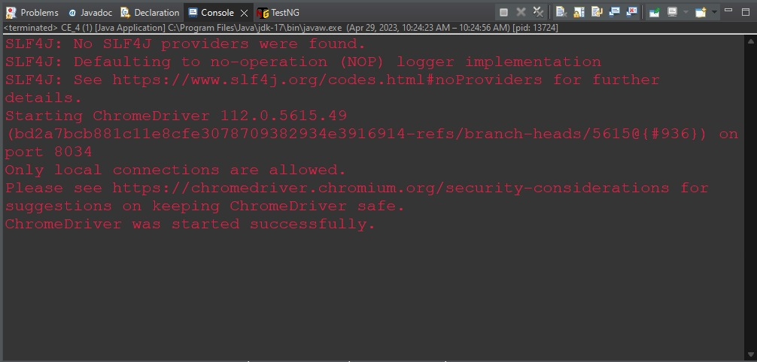

1. **package ClassEx_4;**

**import org.openqa.selenium.By;**

**import org.openqa.selenium.Keys;**

**import org.openqa.selenium.WebDriver;**

**import org.openqa.selenium.WebElement;**

**import org.openqa.selenium.chrome.ChromeDriver;**

**import org.openqa.selenium.chrome.ChromeOptions;**

**import org.openqa.selenium.edge.EdgeDriver;**

**import io.github.bonigarcia.wdm.WebDriverManager;**

**public class CE_5 {**

**public static void main(String[] args) {**

**ChromeOptions co = new ChromeOptions();**

**co.addArguments("--remote-cross-origin=*");**

**WebDriverManager.chromedriver().setup();**

**WebDriver driver1 = new ChromeDriver();**

**driver1.get("https://www.google.com/");**

**driver1.manage().window().maximize();**

**WebElement search1 = driver1.findElement(By.xpath("//*[@id=\"APjFqb\"]"));**

**search1.sendKeys("Apple");**

**search1.sendKeys(Keys.ENTER);**

**String currentWindowId1 = driver1.getWindowHandle();**

**String currentTitle1 = driver1.getTitle();**

**System.out.println("Window Id 1 : " + currentWindowId1);**

**System.out.println("Window Title 1 : " + currentTitle1);**

**driver1.quit();**

**WebDriver driver2 = new EdgeDriver();**

**driver2.get("https://www.google.com/");**

**driver2.manage().window().maximize();**

**WebElement search2 = driver2.findElement(By.xpath("//*[@id=\"APjFqb\"]"));**

**search2.sendKeys("Selenium");**

**search2.sendKeys(Keys.ENTER);**

**String currentWindowId2 = driver2.getWindowHandle();**

**String currentTitle2 = driver2.getTitle();**

**System.out.println("Window Id 2 : " + currentWindowId2);**

**System.out.println("Window Title 2 : " + currentTitle2);**

**driver2.quit();**

**ChromeOptions co1 = new ChromeOptions();**

**co1.setBinary("C:\\Program Files\\BraveSoftware\\Brave-Browser\\Application\\brave.exe");**

**WebDriver driver3 = new ChromeDriver(co1);**

**driver3.get("https://www.google.com/");**

**driver3.manage().window().maximize();**

**WebElement search3 = driver3.findElement(By.xpath("//*[@id=\"APjFqb\"]"));**

**search3.sendKeys("Cucumber");**

**search3.sendKeys(Keys.ENTER);**

**String currentWindowId3 = driver3.getWindowHandle();**

**String currentTitle3 = driver3.getTitle();**

**System.out.println("Window Id 3 : " + currentWindowId3);**

**System.out.println("Window Title 3 : " + currentTitle3);**

**driver3.quit();**

**}**

**}**

**OUTPUT:**

